Skill40_Editorial_Logos > Skill40_Editorial_Studios

Skill40_Editorial_Logos > Skill40_Editorial_Visitei

Skill40_Editorial_QR-Code > Skill40_Editorial_QR-Code

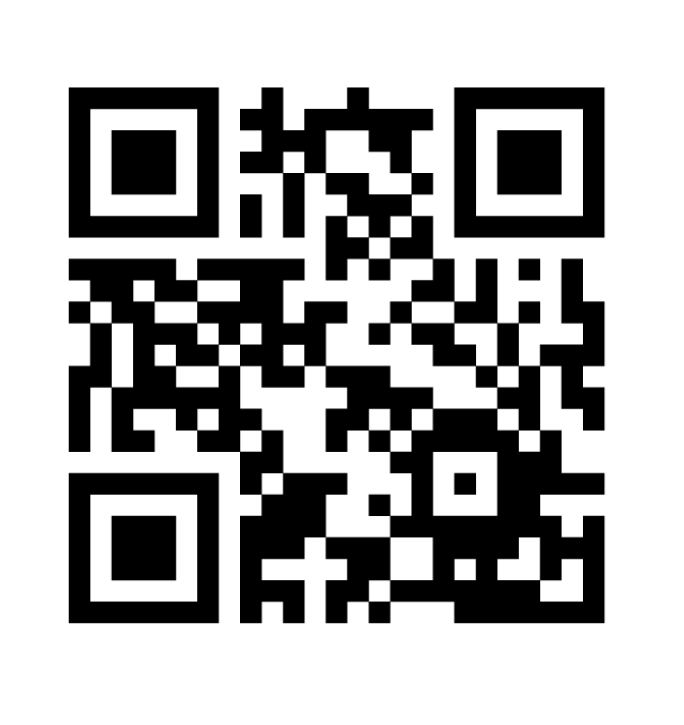

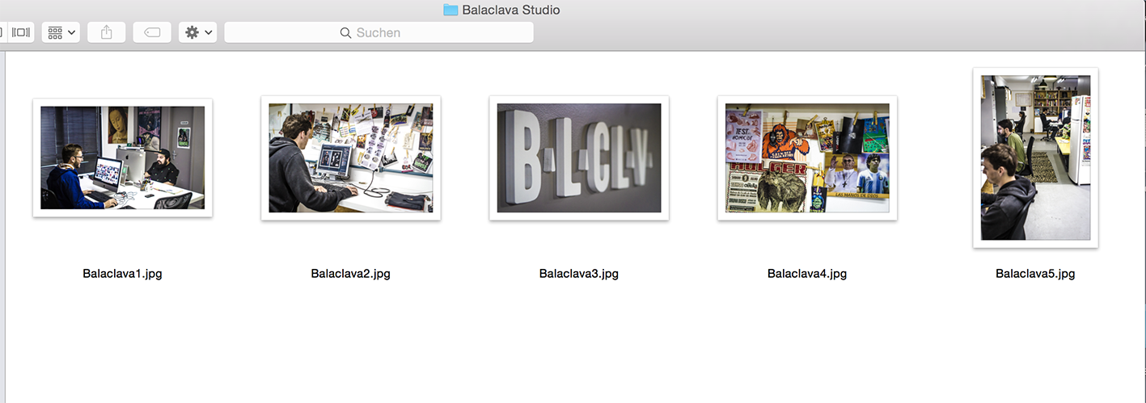
Skill40_Editorial_Images > Skill40_Editorial_Images

Studio Balaclava

Studio Bradda
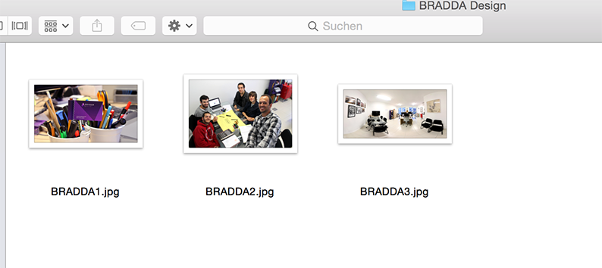

Studio Cafundo
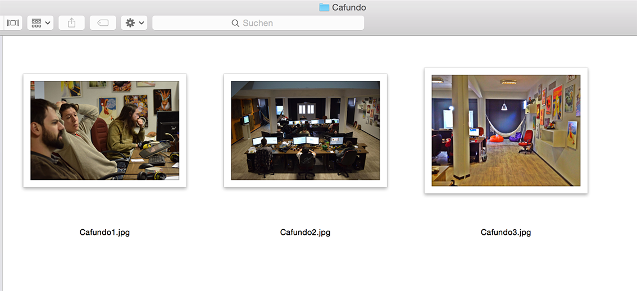

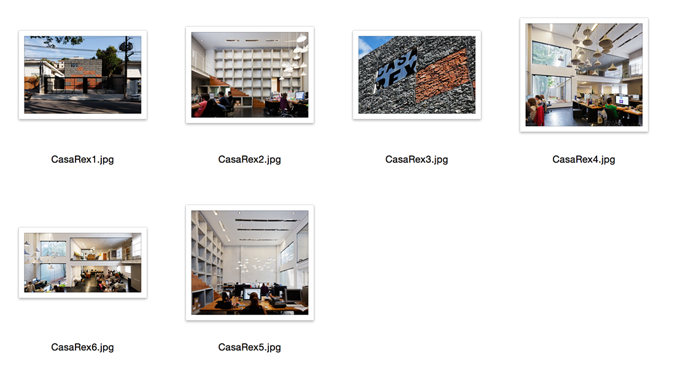
Studio CasaRex

Studio EstudioMarujo
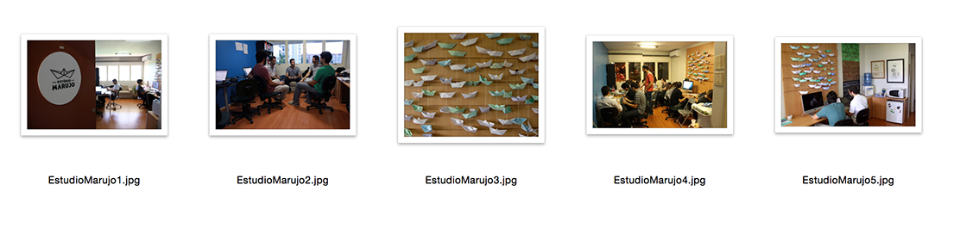

Studio FIB
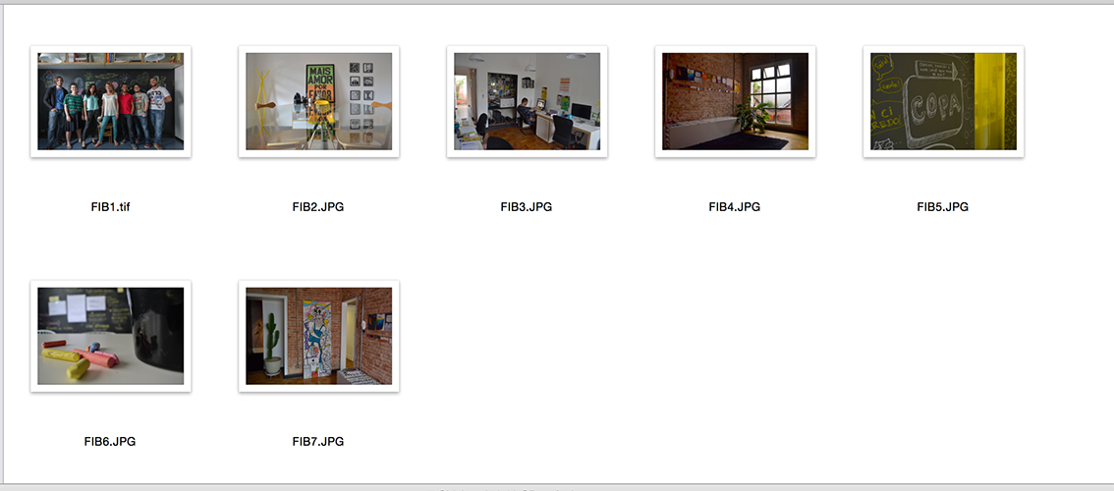

Studio Globulo
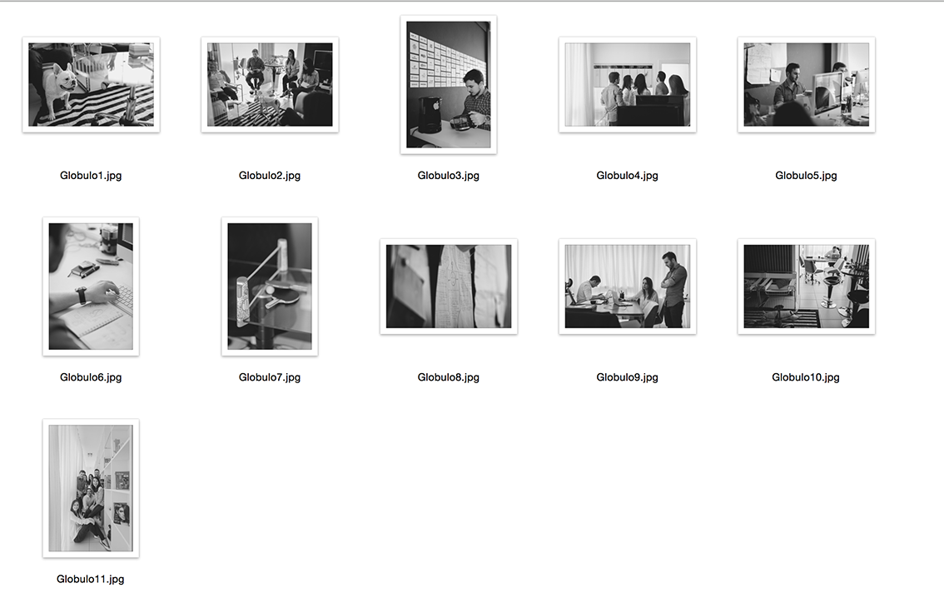

Studio OniBranding

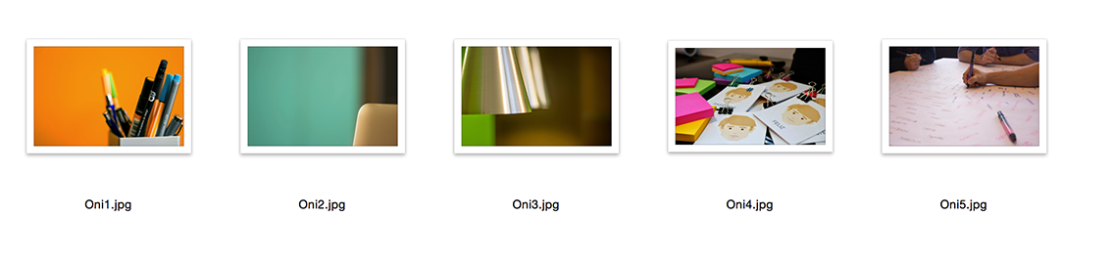

Studio oodEstudio
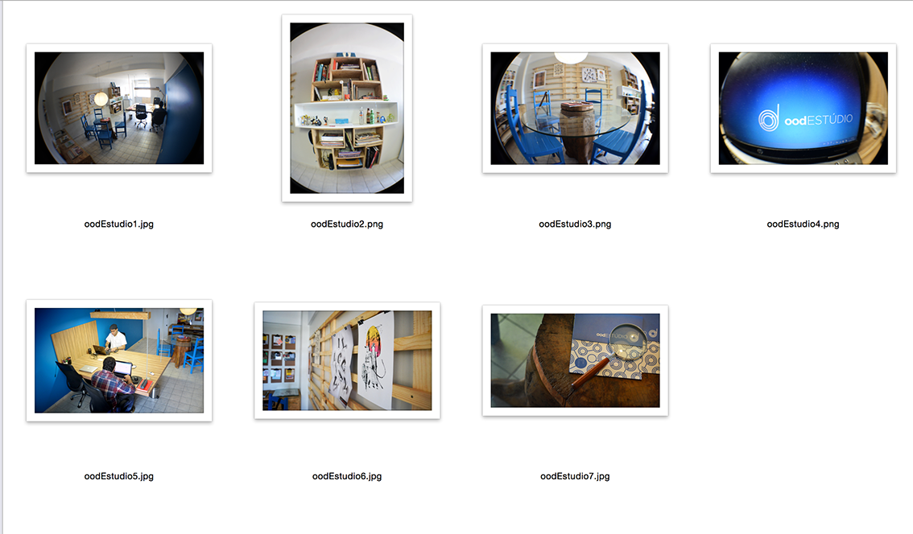


Studio Questto

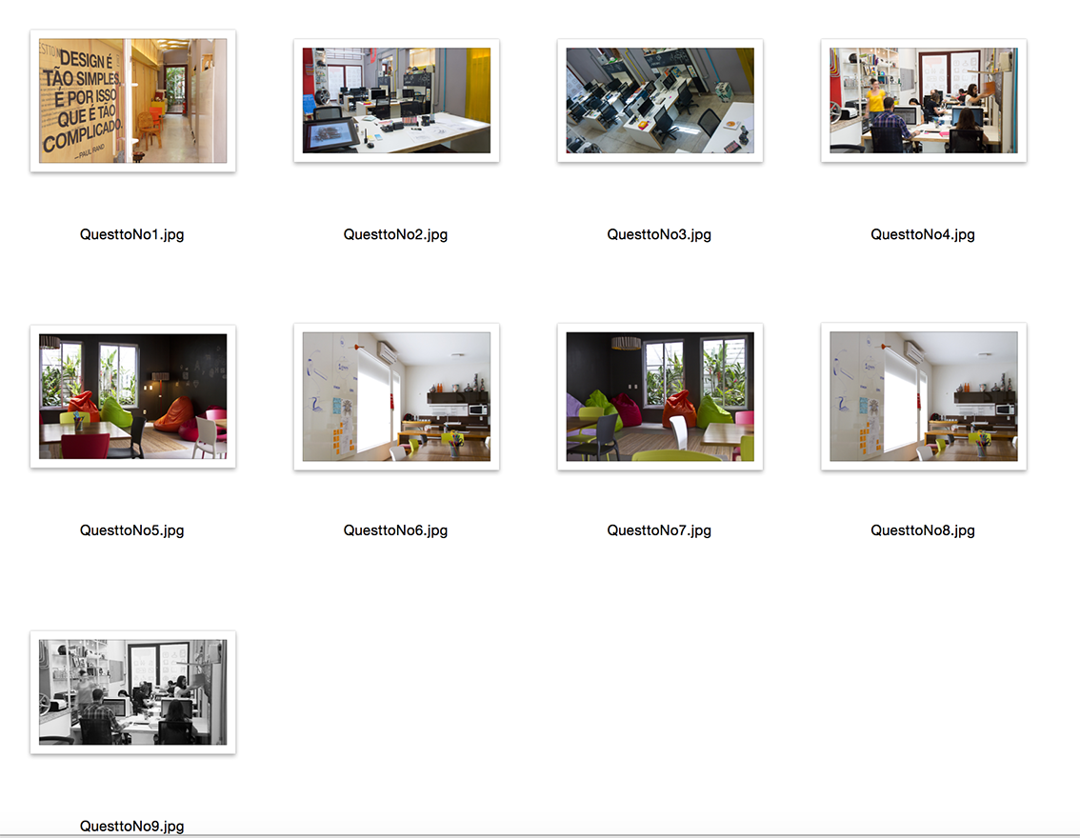


Studio Sebastiany
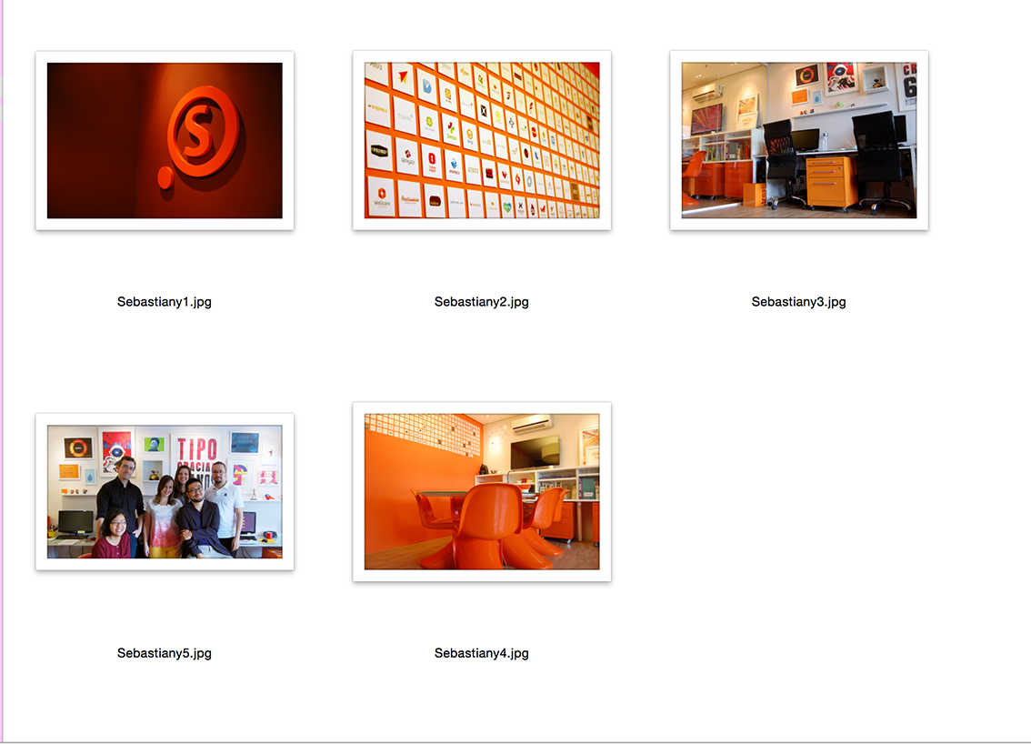

Studio UnoBrand

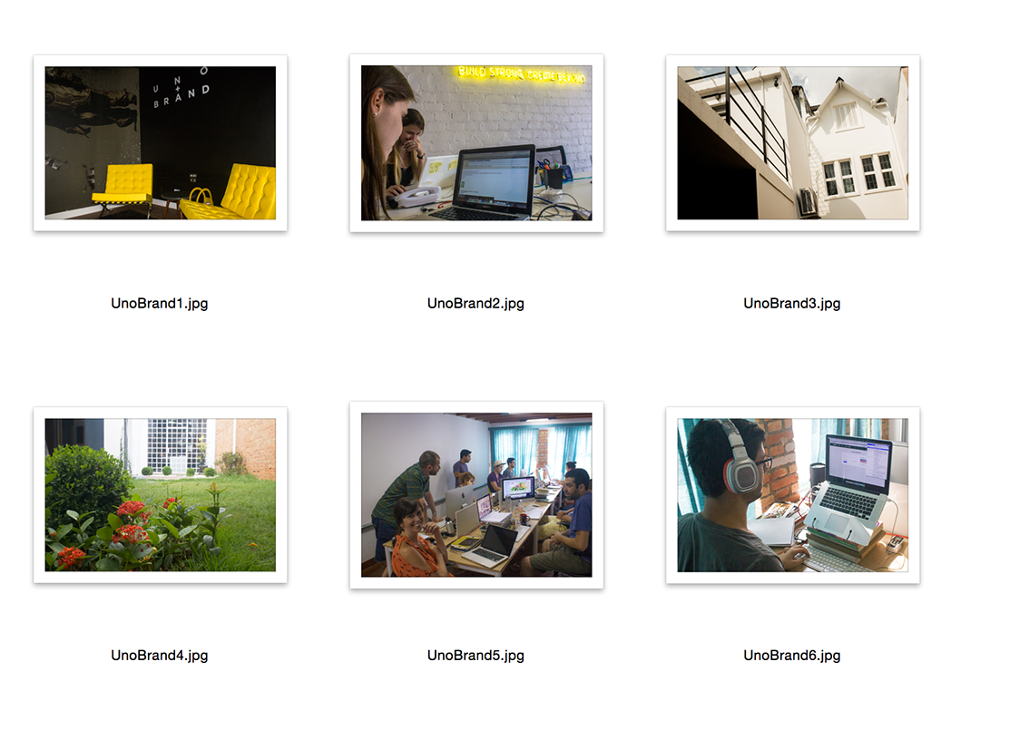

Image Giovani
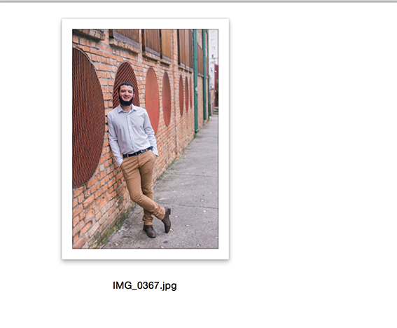

Image Maps
